Compact Automated Waste Sorter

Clyde Bujari, Troy Rzeznikiewicz, Melissa Siver, and Juan Soto

Dept. of Electrical and Computer Engineering, University of Central Florida, Orlando, Florida, 32816-2450
Abstract — Spectrometers are on the cutting edge of industrial waste sorting solutions. Spectrometry was applied to a mechanical conveyor system to create a novel waste disposal method aimed at reducing or eliminating inaccurate recycling in the public sector. Waste is delivered to the optical system in under 10 seconds, with less than a 1 second execution time for identification. Plastics were sorted with greater than 90% accuracy via near-infrared wavelengths between 960 and 1650 nm. Non light-source systems were driven with solar power for minimal environmental impact. Evaluation of the design was performed with Zemax and other simulation software. The result of the project is a fully functioning prototype that exceeds design specifications.
Index Terms — AC motors, Infrared sensors, Infrared spectra, Microcontrollers, Photonics, Spectral analysis

I. Introduction
The consumer-driven lifestyle enjoyed by industrialized countries drives the indefinite increase of both resource consumption and waste production. These destructive behaviors can be offset by efficient recycling practices, saving both taxpayer money and previously un-recycled resources. The importance of recycling is evident. Public spaces offer a prime opportunity for engineering solutions to improve the rate of recycling. The Compact Automated Waste Sorter (CAWS) is a novel method of in-can waste sorting developed to offer a hands-off approach to recyclable identification and separation.
The concept of the CAWS is to quickly sort waste as it passes through the system by means of waste chute, conveyor belt, and optical system. This goal was accomplished through the utilization of an Ocean Insight near-infrared spectrometer operating in the 960-1650 nm wavelength range. The captured spectrums are matched against a custom-made database of plastic reflection spectrums for materials that are known to be recyclable. The transportation mechanism of the waste through the optical system is an upcycled treadmill conveyor assembly mounted to a custom-built frame.
The process of moving items from entry to exit is managed entirely by the ATmega328P microcontroller at the heart of the system’s PCB. The process is triggered by infrared sensors at the entry, after which a quadrature encoder is used to align items with the optical subsystem for spectral analysis. Spectral data capture and analysis is handled by a Raspberry Pi 4 running a custom identification algorithm. Once an item’s spectrum has been processed by this secondary processor, a servo motor directs the item to its correct destination. An overview of the CAWS design can be seen in figure 1.
The CAWS, inspired by industry-standard recycling facilities, is the first portable implementation of spectrometer-driven automatic waste sorting. The CAWS’s ability to sort waste with greater than 90% accuracy in less than 6 seconds makes it a perfect candidate for effective public implementation. The adoption of in-can automated recycling is one small action for man, and one large change for mankind.

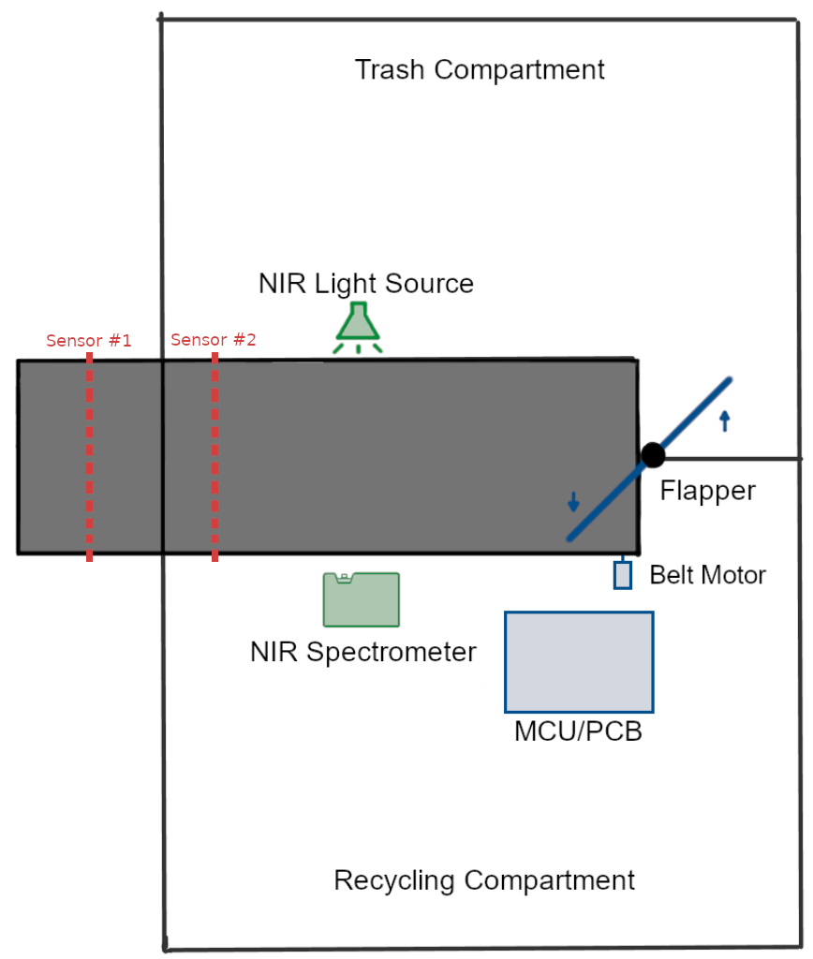
Figure 1. CAWS overview diagram.

II. Goals
The heart of the CAWS is achieving the goal of possible implementation anywhere there is a post-consumer waste bin. The main engineering goals selected to accomplish this function focused on speed and accuracy as the CAWS was designed to lead the industry standard of public waste disposal. The CAWS needed to be fast: the time from object insertion to spectrum acquisition needed to be less than 10 seconds, and the time for sorting program execution needed to be less than 1. The CAWS needed to be accurate: the optical system had to operate within the operational spectrum range of 960-1650 nm for optimal accuracy. Success was achieved and yielded a sorting accuracy of greater than 90%. The results of the spectrometer were displayed on a LCD screen, therefore fulfilling one of our stretch goals.
CAWS is a proof of concept to test and optimize the sorting algorithm before attempting parallelization. Three main prototype limitations are present in the current version, which is built with future revisions in mind. The first of these is the waste delivery method. The current optical system cannot “see” more than one piece of waste at a time, meaning that each object must be inserted individually. Practical application would require that the system be ready for trash that tends to be deposited in masses, as tends to be the case with most public situations. To circumvent this limitation, a simple chute design has been devised to limit a user’s ability to put multiple items in at the same time. A further improvement of this solution would be to create a rotating hopper to ensure that waste is deposited into the system piece by piece in a manner akin to a paintball gun. This would assure that objects would not enter the system at a higher rate than the CAWS’s waste processing speed.
Live deployment would expose another prototype design limitation: waterproofing. It’s not uncommon for consumers to throw away entirely unconsumed and unsecured drinks. Optical systems are sensitive, and any water intrusion could provide faulty readings and damage the components. Future iterations would solve this issue with IR transmissive, easily cleaned shielding. The space for this modification has already been accounted for in the current design.
Other future improvements focus on improved recyclable recognition and spectrum acquisition. This would be accomplished by adding a second optical system to the CAWS, therefore expanding the recognized spectrums for recyclables such as cans and cardboard boxes. End-of-line suction would also be added for recyclables such as plastic bags.

III. Subsystems
Our system is best understood when it is broken down into its individual components. This section gives a simple break-down for each of our components and a brief rationale as to why they were chosen. Many of these components were selected during the design phase of Senior Design 1 of the summer semester, 2021.
- Optical Subsystem
The optical subsystem relies on wavelength range and placement for its success. Spectrometers are an incredibly useful method to identify substances based on their interactions with light. Reflection spectrometry was chosen to simplify the challenging geometry that waste can possibly present to the CAWS system. CAWS is designed to identify plastics. Most plastic waste that would be disposed of in regular trash cans would more than likely be in bottle form, which generally means a cylindrical object. This geometry is most easily navigated through reflection spectrometry since light’s reflection can be predicted well in this scenario. A non-sequential Zemax simulation of the lens and light setup is pictured in figure 2. This simulation and supporting calculations indicate that the amount of light incident upon the lens exceeds the required amount of light needed for a spectrum to be acquired.

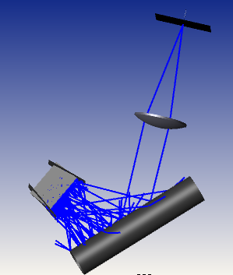

Figure 2. Zemax simulation demonstrating incident light and reflection into the system.

Plastic is most easily identified in the near-infrared range of 960-1650. The Ocean Insight near-infrared spectrometer used in this design is advertised as a large-scale solution for recycling specifically for this reason [1]. Its implementation makes the CAWS system a rival to industrial waste sorting.
Lens positioning is based on the reflection and collection of light at -45- and 45-degree angles from the sample, respectively. Collection is performed parallel to the conveyer belt to avoid height-related geometry challenges that would have been presented by other positions.
The light and lens are positioned at roughly the same distance from the target sample’s location. The light’s positioning was determined through simulation and experimentation and was optimized for maximum unhindered light transmission. The light source is not strong enough for saturation to occur, so no filters were applied to the assembly. The lens was positioned so that the sample was at its focal point for maximum light collection. The fiber was similarly positioned at the lens’s rear focal point for the same reason. Both lens and fiber were mounted on 3D printed holders designed in-house in Solidworks.
- PCB and Electronics
The mechanical system is controlled by a small array of relays and H-bridges embedded in the printed circuit board. The relay interconnection opens and closes circuits that can operate at a maximum of 250VAC, which allows the CAWS to employ high-power lights and motors if required.
These relays can be powered directly by the battery, which lessens the load on the 5V linear voltage regulator that powers the H-bridges, infrared-red sensors, and microprocessor. To operate a relay, the microprocessor enables a heatsinked transistor that in turn energizes the relay coil; all while employing less than 20mA of current. This system is the primary driver of the light source.
H-Bridge integrated circuitry is the primary driver of the conveyor belt. Given that waste must be scanned with uniform lightning and placement, it is imperative to have precise control over the belt’s speed and position. This is achieved through a high-power BD63150AFM H-Bridge microchip embedded in the PCB, which allows precise speed modulation and can operate at currents beyond 5A. By using PWM signals between the microprocessor and H-Bridge chip, an appropriate belt ramp-up speed can be selected which is important to prevent waste from sliding on the belt and guaranteeing encoder accuracy.
The 12V DC motor selected to operate the CAWSS’s conveyor belt features a quadrature encoder, which is used by the microprocessor to deduce the item’s position. Employing an encoder with an acceptable resolution is critical for placing waste accurately on the scanning location; the quadrature encoder has a resolution of 145 pulses per revolution of the motor’s output shaft. Using a 2-inch pulley attached to the output shaft, the microprocessor then records a belt movement of 6.3 inches for every 145 encoder pulses. When waste input is sensed by the IR sensors, the H-Bridge chip will be signaled to operate until 500 pulses are read by the microprocessor.
All system functionality is commanded by or otherwise routed through an ATmega328P microcontroller. As this is a 28-pin DIP part, it can be directly socketed into the PCB. This allows for much simpler assembly and prototyping than with surface-mount controller packages that cannot be easily hand-soldered.

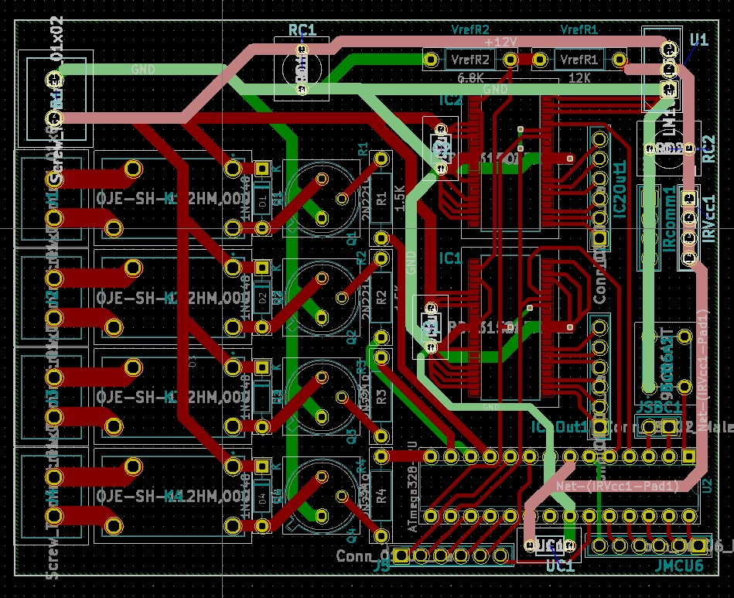

Figure 3. PCB

Some system functionality cannot be handled by the ATmega controller on its own; while all functionality ultimately depends on this controller, the task of collecting and analyzing spectral data is handled externally by a Raspberry Pi 4.
The decision to use a secondary processor was made for several reasons. A microcontroller can theoretically execute the spectral analysis algorithm (after heavy modifications and reimplementation of unavailable Python libraries) and interface directly with the Flame NIR via the I2C, SPI, or UART protocols. However, doing so requires the use of an expansion port whose connector type was discontinued several years ago. It would also have required much more reverse engineering than the time constraints of this project would allow for, to avoid potentially damaging a very expensive piece of hardware.
- Microcontroller Software
The software design for the ATmega328P microcontroller is structurally simple, but critical to the proper functioning of all parts of the CAWS system. As the diagram in Figure __ illustrates, the ATmega waits for most of its time in a low-power state. It can only be woken from this state when the IR sensor at the entrance is tripped, triggering an interrupt service routine. The H-bridge is then sent a PWM signal to run the belt motor at a known speed.
As the item travels along the belt, it passes a second IR sensor. This sensor is used in conjunction with the motor’s built-in encoder to approximate the length of the item. This value can be used to center the item in front of the optical assembly as much as possible; the system assumes that the midpoint of the item is the ideal point to take a spectral reading, and so uses that value to estimate a target for the encoder to reach before stopping the belt.
Once the item has reached its target position, the halogen lamp used as an infrared light source is turned on via one of the relays on the PCB, and a logic HIGH trigger signal is sent to the Raspberry Pi. The ATmega then waits for two signals from the Pi: the first is another logic HIGH trigger signal, telling the ATmega that analysis is complete. The second represents the actual result of the analysis - a logical HIGH represents a recyclable item, and a logical LOW represents a non-recyclable one.
The ATmega then directs the servo to the proper position for the item, turns off the halogen lamp, and runs the belt motor again - long enough for the item to fall to its destination. This process takes no longer than a few seconds, and the lamp (a major source of heat) is only turned on for a second or two at most.
- Spectral Analysis Software
The software design for the Raspberry Pi 4 microcomputer is separate from the ATmega and supports the most complex part of the system. Spectrum collection is handled via the open-source Seabreeze API [2], and specifically the python-seabreeze [3] community port of this API. This library handles all USB communication with Ocean Insight spectrometers, providing a simple, clean interface to manage the device and collect spectral data.
On initial startup, the Pi establishes a connection to the Flame NIR, sets the integration time to the default 100 ms, and requests a list of the spectrometer’s wavelengths to create the x-axis of all spectral readings. Finally, the Pi requests a spectral reading from the Flame. This first reading, taken long before the lamp is turned on, serves as a reference “dark spectrum”. This reference is subtracted from each item spectrum as they are taken, effectively removing any constant background sources of infrared noise that are not blocked by the housing.
After completing all initialization tasks for the spectrometer, the software also automatically loads a custom database of known recyclables, as well as a second, smaller database of non-recyclables that are known to cause false positive matches to the primary database. These two databases were formed by aligning known test items within the fully assembled housing and optical subsystems at multiple possible angles, and manually directing the Pi to their spectra into their respective databases. These databases are not large enough to justify using fully-fledged database software; instead, the software makes use of Python’s pickle object serialization package. This package allows Python objects, like a simple dictionary of known spectra, to be saved to disk for long-term storage.
As discussed briefly in the previous software section, spectrum collection and analysis is triggered by a logic HIGH input to one of the Pi’s GPIO pins. The Pi has no support for microcontroller-style power modes, so it simply waits in a while loop until a rising-edge event is detected on the input pin. When this occurs, a call is made to the spec.intensities() function, which returns the current spectral reading from the Flame NIR. This reading is saved for later display, and then passed to the database_compare() helper function to compare it to each spectrum from the database.
Comparison of infrared spectra is ultimately a comparison of two or more 1-dimensional matrices. As a result, many robust statistical approaches to do so already exist. The most accurate of these methods tested was to calculate the Pearson correlation coefficient of a pair of spectra. This coefficient is a measure of linear correlation between any two datasets (X and Y, respectively), found by taking the ratio between the covariance of the two, and the product of their standard deviations.

$ρ_{X,Y}= \frac{cov\left(X,Y\right)}{σ_{X}σ_{Y}}$ (1)

This calculation is neatly abstracted by the SciPy statistics package for Python. The database_compare() function simply iterates through the database, passing each entry, as well as the input spectrum being compared, to the stats.pearsonr() function imported from SciPy. Thanks to the small size of the database as well as the Pi’s processing power, a comparison to all entries takes only about 0.2 seconds on average.
To be considered a match to a database entry, a spectrum’s Pearson coefficient with that entry must be ≥ 0.98. This was found to be a more than sufficient threshold to accurately identify matches between each plastic type. In the case where a valid match was found to the recyclable database, and not the false-positive database, the item is identified as recyclable - conversely, if there was no match, or only a match to the false-positive database, the item is identified as non-recyclable. In the case where an item produces a valid match to both databases, the highest coefficient found from each database will be compared; the item will be classified as the higher of the two database entries. The result of this analysis is sent back to the ATmega microcontroller as discussed in the previous subsection.
Though the analysis software has completed its task at this point, one of the stretch goals for the system was to represent this process to users of the CAWS in a tangible way.
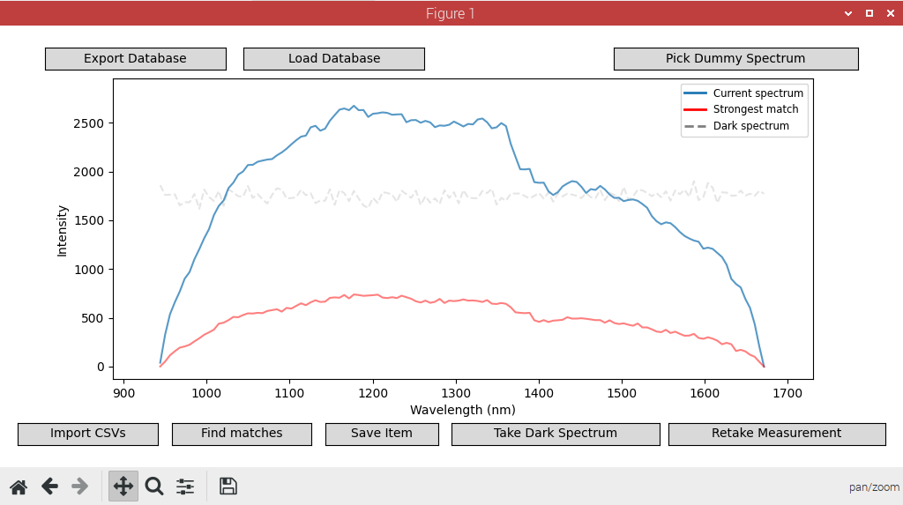
Figure 4. Screenshot of Spectrum Display

A 7-inch display is connected to the Pi for this purpose, displaying the spectrum of the inserted item (in blue) and the spectrum of the closest match from the database (in red) using Python’s robust Matplotlib package.

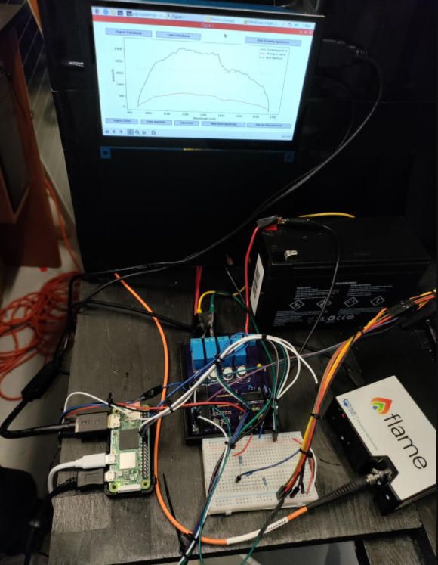

Figure 5. Electricals system, spectrometer, and display screen.

IV. Component Selection
- Spectrometer
The Ocean Insight NIR spectrometer was selected because of availability and ease of implementation. Its function is to process incoming light and output a usable spectrum. It limits the rest of the optical system via its numerical aperture of 0.22 and its wavelength range of 0.96-1.65 um. The resolution of the system was calculated via the Rayleigh equation:

$\sin{θ_{r}}=\frac{λ}{D}$ (2)

where lambda is the central wavelength and d is the slit size. The 25 um entrance slit results in a 2.934 degree separation between features when its central wavelength is considered. This resolution was converted to resolution in terms of pixels, which yielded a resolution of 1.9 nm FWHM. This affected the reflection spectrums collected and had to be taken into consideration when the spectrum processing software was developed.
- Collector Lens
A light focusing element was needed for optimal light delivery into the fiber optic cable being used to deliver light to the spectrometer. After various simulations in Zemax, our team determined that a lens was the most compact and efficient way to collect the 0.960-1.65 um light being reflected from the sample. The Thorlabs N-BK7 Plano-Convex Lens (LA1002) lens was selected, as it was a cost effective and simple solution that solved the problem at hand. This 75 mm N-BK7 lens has an antireflective C-coating with greater than 90% transmission between 0.9-1.7 um, which was selected to maximize the light collected by the system [4]. The selected diameter was chosen for two reasons: its ability to collect light and its numerical aperture. A focal length of 150 mm was selected to fulfill the numerical aperture requirements of the fiber. The numerical aperture of a lens can be calculated via the equation:
$NA= \frac{D}{2F}$ (3)

where D is the diameter and f is the focal length. This resulted in a numerical aperture of 0.25 when applied to the selected lens. This is only slightly larger than the fiber’s numerical aperture of 0.22, meaning that nearly all light entering the system is traveling at an angle that will be accepted by the fiber. Ultimately this lens was mounted in a 3D-printed lens holder designed by the CAWS team.

Fiber
The fiber was selected to match our spectrometer’s numerical aperture while still maximizing light transmission. The selection of the Thorlabs FG200LCC step index multimode optical fiber was made based on its numerical aperture and its light transmitting abilities. The 0.22 numerical aperture matches that of the spectrometer and is only slightly smaller than the lens, assuring that nearly all of the light entering the system will be accepted by the spectrometer. It’s 200 um core is large and carries over 12,000 supported modes, calculated with the equation

$M= \frac{2π(a)(NA)}{2λ}$ (4)

where M is the number of modes, lambda is the central wavelength, a is the radius, and NA is the numerical aperture of the fiber. The large number of modes accommodated allows much of the incoming light to be transmitted by the fiber. The fiber was positioned and held in place by a 3D printed fiber holder designed by the CAWS team.
- Light Source
Spectrometry requires a light source that emits light within the wavelength range under consideration. CAWS’s waste-sorting application required a broadband light source that emitted NIR wavelengths with enough power to hit the object and then reflect into the optical system. The broad-band emission requirement eliminated LEDs from consideration; their individual spectrums are very limited, and therefore a massive LED array would be required for proper illumination. This follows with the traditional practice of using sources such as flashlamps for spectrometer illumination.
The most practical way of generating a broad spectrum is blackbody radiation. The Wein’s Law equation is

$λ= \frac{b}{T}$ (5)

where lambda is the central wavelength, b is Wein’s displacement constant, and T is the temperature of the body in Kelvins. Wein’s Law was used to calculate the temperature needed for blackbody radiation centered around our preferred wavelengths. This calculation gives an optimal temperature of 2200 K for the needed light source.
Incandescent and halogen bulbs output radiation temperatures of 2000-3000K. The output spectrum of halogen bulbs is influenced by the gas, however, and is concentrated more significantly to the left of the near infrared spectrum. Incandescent bulbs have smoother emission spectrums; an incandescent bulb was chosen for this reason. A 250 incandescent HDX work light was installed as the light source. It is caged on 3 sides by a mirror system that reflects most light towards the sample under analysis.
- Structure
A lid was designed to prevent stray light incursions and damage to the optical system. This component was constructed out of PP plate sheet, otherwise known as fluted polypropylene sheet. The most common form of PP plate sheet is corrugated poster board and was purchased for the project at a craft store. This poster board was cut and glued together with hot glue sticks to retain its shape and structure over time. Holes were cut into the sides to allow for the movement of the conveyor belt and the items being analyzed to be able to pass through it. Those entrances were then covered with fabric to also combat stray light from entering the system.
A large part of the lid structure that was designed was the material that it was made from, which was a polypropylene sheet. Complications occur with using this material because one of the plastics targeted for identification was polypropylene. To prevent complications from arising, a paint called Black 3.0 was used. This is a super matte, ultra-acrylic black paint that has an estimated light absorption of 99% for visible light. Experimental testing showed this paint also reduced reflections for NIR in addition to its absorption of visible light. This paint is what the inside of the lid structure is coated with which can prevent most light reflections from the light source. After testing before and after the application of the paint coating the inside of the lid structure, a significant difference was observed in the accuracy of the results obtained.

Motors, Sensors, and Control Devices
The CAWS’s conveyor belt is driven by a Gobilda 5202 Series Planetary Gear Motor: specifically, the 1150 RPM model. While perhaps more expensive than a generic 12 V motor, this motor has several benefits that made the prototyping process easier.
The motor is robustly constructed and uses a large 6 mm shaft, ensuring that the stress of driving the belt does not damage it. It also provides an extremely useful quadrature encoder that otherwise likely would not have been considered in the design of the CAWS - as discussed previously, this addition allows for precise measurement of the distance the belt has travelled. The motor is controlled through an H-bridge, isolating potential EMF noise that could damage other PCB components and allowing for PWM-based speed control.
Items are directed to their final resting place by a servo motor. While still a small, hobbyist device, this motor was selected for the relatively high torque (up to 21.5 kg/cm) and greater range of motion it provides over cheap generic servos.
For simple detection of an item’s presence, as well as to approximately measure the size of an item as it passes through the system, IR sensors were selected. While there were initial concerns over these sensors potentially interfering with the NIR wavelength band used for spectral analysis, they are safely located outside the main housing where they cannot affect spectrum collection.
The primary light source for the CAWS is operated through a traditional relay. Since selection of the system’s bulb took more care and testing than many other components, a control solution that could support both DC and AC-operated lamps was required. This relay provides this flexibility at a much lower cost than a solid-state relay or fully electronic solutions.

ATmega Microcontroller
All system functionality is commanded by or otherwise routed through an 8-bit ATmega328P microcontroller. It features 2 KB of RAM, 32 KB of long-term flash storage, and operates at a maximum clock speed of 20 MHz. To simplify hardware design and conserve battery power, the controller runs at the 8 MHz clock speed produced by its internal oscillator.
The decision to offload all spectral analysis tasks to a secondary platform (described in the following section) makes the ATmega328P a capable choice to coordinate all digital input/output in the system. Familiarity with the Arduino platform made this part an obvious choice over equivalent offerings like Microchip’s PIC series or TI’s MSP430 series.

Raspberry Pi Microcomputer
CAWS’s spectral analysis software is powered by a Raspberry Pi 4. The decision to use a secondary platform was made for several reasons - in particular, our spectrometer is primarily intended for use with a fully-fledged operating system over USB. It is possible to communicate with the device via protocols like I2C and SPI through its expansion port as well; however, the connector used for this port is no longer readily available. Rather than spending additional development time reverse-engineering how the spectrometer communicates with these protocols and risking damage to this expensive component, the Raspberry Pi allows access to official software packages made by Ocean Insight and community members to safely communicate with the Flame NIR.
Once the decision to use a secondary platform was made, little time needed to be spent on choosing the Raspberry Pi 4 as that platform. While a lower model of the Raspberry Pi would likely provide acceptable performance, the Pi 4 was already owned by a member of the team for use on other projects. As the Pi 4 completes database comparison in a fraction of a second, more robust or x86-based alternatives provide no tangible benefit for their additional cost.

V. Component Selection
The Compact Automated Waste Sorter is a complete prototype that could easily be adapted for public use. The engineering goals set to consider our project a success was: a total sorting time of less than 10 seconds, a program execution time of less than 1 second, and an optical system functioning in the 960-1650 wavelength range. An additional stretch goal of an end-user viewable screen was also reached. The team was required to acquire and apply specialized knowledge of spectrometry, spectrometers, and analysis methods to complete this project. Use of programs outside of major requirements was also required, prompting team members to learn complex statistical analysis, as well as use of software like Zemax, KiCAD, and Solidworks. The team demonstrated their ability to work as a cohesive team during the entirety of the two Senior Design semesters and will be life-long professional contacts. Their ability to function in a professional setting is underlined by their capability to meet industry-style deadlines and to successfully plan and market a project. The completion of the Compact Automated Waste Sorter proves the team’s preparedness to assume the role of engineers.

Acknowledgement
The authors wish to acknowledge the assistance of the Laser Plasma Laboratory at CREOL and Ocean Insight.

References
[1] Y. Mattley, “Spectroscopy for Plastics Recycling,” www.oceaninsight.com, Apr. 14, 2021. https://www.oceaninsight.com/blog/spectroscopy-for-plastics-recycling/ (accessed Nov. 23, 2021).ces
[2] “SeaBreeze API Documentation,” www.oceaninsight.com. https://www.oceaninsight.com/globalassets/catalog-blocks-and-images/software-downloads-installers/javadocs-api/seabreeze/html/index.html (accessed Jul. 13, 2021).
[3] “python-seabreeze: Python module for oceanoptics spectrometers,” GitHub. https://github.com/ap--/python-seabreeze (accessed Jul. 14, 2021).
[4] “Thorlabs - LA1002-C N-BK7 Plano-Convex Lens, Ø75.0 mm, f = 150 mm, AR Coating: 1050 - 1700 nm,” www.thorlabs.com. https://www.thorlabs.com/thorproduct.cfm?partnumber=LA1002-C (accessed Nov. 23, 2021).




